**Lab-00: Change Interface name ens to eth**

##### **Step 1 : Edit grub file Install vim and ssh for ubuntu**

# vim /etc/default/grub

GRUB_CMDLINE_LINUX="net.ifnames=0 biosdevname=0"

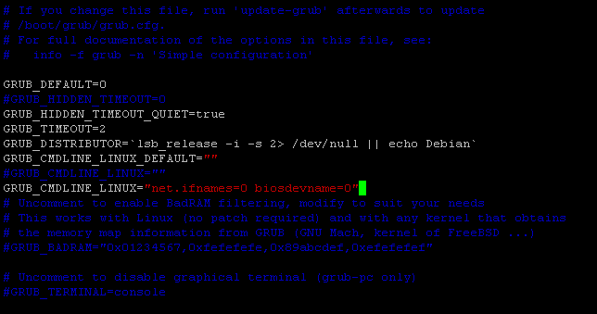

**Step 2 :** **Update grub**

# update-grub

##### 

**Step 3 :** **Configure Network interface (eth0)**

# vim /etc/network/interfaces

# The loopback network interface

auto lo

iface lo inet loopback

# The primary network interface

auto eth0

iface eth0 inet dhcp

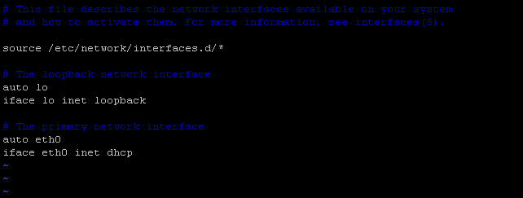

##### **Step 4: Reboot server**

# init 6

**Before**

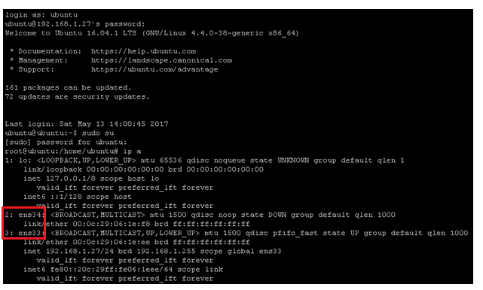

**After**

